# 



**Republic of the Philippines**

**POLYTECHNIC UNIVERSITY OF THE PHILIPPINES**

**COLLEGE OF ENGINEERING**

**COMPUTER ENGINEERING DEPARTMENT**

**IMPLEMENTATION OF**

**ATTENDANCE WITH BIOMETRICS, INVENTORY, FISH DISPERSAL AND, FISH PRODUCTION SYSTEMS**

SUBMITTED BY:

Jamlang, Teejay Y.

Pol, Roman Tristan A.

Punzalan, Daniel James M.

Suinan, Angelo Nichol A.

SUBMITTED TO:

Engr. Julian Lorico Jr.

## ACKNOWLEDGEMENT

It took nearly two months to finally come up with a group project on **AN ATTENDANCE WITH BIOMETRICS, INVENTORY, FISH DISPERSAL AND, FISH PRODUCTION SYSTEM.** We would like to thank people who have helped us throughout the duration of project development.

We grateful to our Professor lecturers for the knowledge they gave us. Namely Engr. Julian Lorico Jr., Dr Arvin Dela Cruz, Engr Pedrito Tenerife Jr and Dr Lutzer Reyes. Their continuous help and support made the project feasible.

There are no exact words to express our regards and reasonable gratitude to BFAR-NIFTC-TANAY, RIZAL, without them this project could not get an entrance towards the execution. To Mr. Adan S. Diamante and Mr. Romualdo Pol who assisted and permit us from the Thesis I and II up to this Project. We are indebted to them for giving us this great opportunity to pursue our project and for their hospitality.

Last, but not the least we would like to thank our parents for supporting us every step of the way.

Lastly, we would like to thank all those whose names may not have appeared here but whose contribution has not gone unnoticed. We would like to thank all of them, for their help in various ways.

### TABLE OF CONTENTS

1. Acknowledgment ……………………………………………………………………………. 2
2. CHAPTER I – Company Background
   1. History of the Company ……………………………………………………………. 4
   2. Vision and Mission ………………………………………………………………… 5
   3. Organizational Structure …………………………………………………………… 7
   4. Area Layout ……………………………………………………………………...… 12
3. CHAPTER II – System Analysis
   1. Business Processes …………………………………………………………………. 13
   2. Problem Definition ………………………………………………………………… 16
   3. Proposed Solution ………………………………………………………………….. 16
   4. Significance of the Study …………………………………………………………... 17
   5. Scope ……………………………………………………………………………….. 17
   6. Limitation …………………………………………………………………………... 19
4. CHAPTER III – System Design
   1. Business Processes …………………………………………………………………. 20
   2. Data Flow Diagram ………………………………………………………………… 31
   3. Entity-Relationship Diagram ………………………………………………………. 36
5. CHAPTER IV – System Feasibility
   1. Proposed Solution ………………………………………………………………….. 43
   2. Alternative Solution ……………………………………………………………...… 52
6. Appendices ………………………………………………………………………………….. 60

## Chapter I. COMPANY BACKGROUND

### 

### HISTORY OF THE COMPANY

The National Inland Fisheries Technology Center (NIFTC) traces its roots from the one-hectare provincial fishery project established by the province of Rizal in 1939, primarily for the collection and identification of flora and fauna of Laguna de Bay. After the war in 1947, it was transferred to the Division of Fisheries under the Department of Agriculture and Commerce and was renamed Tanay Limnological Station.

In 1954, it was expanded to 2.5 hectares and developed as the Central Luzon Demonstration Fish Farm for the culture of freshwater fishes under the Bureau of Fisheries. It was later expanded into the three hectares and renamed Tanay Freshwater Experimental Station under the Philippine Fisheries Commission. The station was renamed as Tanay Research Laboratory in 1970 and its main thrust was mass production of carps.

With the reconstitution of BFAR as a line bureau, the station was designated as the national center for carp production and research. The center is located at Km 52 Manila East Road, Suyoc, Tanay, Rizal. It is accessible by both the old provincial road and the Manila East Road.

### VISION AND MISSION

**VISION**

A progressive aquaculture industry that is technologically advance and sustainable inland water resources providing basic ecological services and food for the people.

**MISSION**

To improve fisheries productivity within ecological limits and promote sustainable development, conservation and enhancement of our fisheries resources in inland waters and empower fisher folk towards food security

**FUNCTIONS AND OBJECTIVES**

**FUNCTIONS**

* Maintain a National germplasm center for cyprinids and labyrinthine species.
* Organize and establish a network of satellite cyprinids and labyrinthine multiplier stations in selected strategic regions to produce quality fingerlings for dispersal to fish farmers.
* Develop, package and disseminate appropriate commodity based aquaculture technologies through the regional research outreach stations for replication and adoption by the freshwater aquaculture sub-sector.
* Implement a national commodity based fish stocking program to rehabilitate inland water resource in coordination with FARMC’s, LGU’s and relevant Resource Management Agencies/Councils.
* Provide assistance in capacity building and coordinate with FARMC’s and LGU’s in the management of inland water resources.
* Organize and implement specialized training courses to upgrade the skills and competencies of fish farmer managers/ technicians and scientist.
* Provide specialized and commodity based technical assistance/advisory services to aquaculture project management and operation.

**OBJECTIVES**

Serve as the Philippine germplasm center for carps & labyrinthine species, develop and enhance our inland water resources through multi-sectorial approach for inland resource conservation and management.

### ORGANIZATION STRUCTURE

Hatchery Operation Unit

Farm Operation Unit

**PERSONNEL/STAFF:**

Aquaculturist I

Aquaculture Technologist

Master Fisherman

3 Farm Workers

Fry/Fingerling

Dispersal Unit

AQUAPARK & Live Freshwater Fishes Museum Unit

Research Unit

Training Unit

**PERSONNEL/STAFF:**

Senior Aquaculturist

Administrative Aide

Research Assistant

Utility Worker

Organic Aquaculture & Feed Development Unit

IEC Unit

BASIL

**PERSONNEL/STAFF:**

Agricultural Engineer

Research Assistant

Security Guard/Driver

Knifefish Project

Water Quality & Natural Food Production Unit

**Fingerling Production and Dispersal Section**

**Technology Verification and Outreach Section**

**Inland Resource Management Section**

**BFAR-NATIONAL DIRECTOR**

**BFAR-NIFTC Center Chief**

*Officer-In-Charge*

**PERSONNEL/STAFF:**

Administrative Aide

Information Technologist

Driver

**Assistant Director for Technical Services**

**Figure 1** Organizational diagram

**Permanent Permanent**

Adan S. Diamante (Aquaculturist II) Romualdo Pol (Sr. Aquaculturist)

Rosebella Valencia (Aquaculturist I) Nicanor Crisostomo (Security Guard I )

Danilo Sinquenco (Administrative Aide III)

**4 Job Orders** **(Production)** **3 Job Orders (Technical)**

* Pepito Bicera Jr. (Laborer) * Marvin F. Costo (Job Order, BS Biologist)

* Rolando Magalona (Laborer) * Julius Aran (Job Order, BS Biologist)

* Rodrigo Lofranco (Laborer) * Ferdinand Vocal (Job Order, BS Fisheries)

* Rowel Bautista (Laborer)

* Ronald Gimenez

**1 Job Order 1 Job Order**

* Lyn San Jose (RA Knifefish, BS Fisheries) * Jasper Paul Ancheta (Agricultural Engineer, NIFEP)

The Center occupies a total area of 3.1 has consisting of:

✓ 2 single detached dormitory

* Capacity of 16 persons
* With individual toilet and bath
* Cushioned bed
* Aircon type ventilation

✓ Training dormitory Building

* Capacity 43 persons with separate toilet and bath, cushioned bed, and aircon
* 150 square meter conference room capacity 50 persons with separate toilet
* Social and recreational area
* Mess hall/dining detached, two story.

✓ Administration building

* Wet laboratory
* Store room
* Reception area
* Offices with built-in 3 unit comfort room

✓ Invasive fishes information center/I.T room

✓ Multi-purpose building

* • 3 bedroom guesthouse with common toilet and bath
* • 4 units conditioning / hatchery tanks
* Storeroom

✓ Old administrative building

* Power house
* Fish/health water quality laboratory
* Audio-visual room

✓ Hatchery building

1. Main Hatchery
2. Water Tank
3. 9 units concrete spawning tanks
4. 1 unit concrete water reservoir
5. 12 units hatching jars with funnel type hatching cloth
6. 5 units hatching funnels (fiber glass)
7. 2 units of aeration system
8. 2 units freezer
9. 46 sets of aquarium (50 galloons)
10. 10. 7 sets of aquarium (20 galloons)

* Organic Feed laboratory with feed store room, solar dryer and feed processing equipment
* Indigenous Fish Hatchery with 10 units fiber glass tank
* Quarantine facilities with 2 units containment ponds and 2 fiber glass tanks.
* Farm facilities
* 2 units rock pool
* 2 units experimental ponds
* 12 units concrete circular tanks pool
* 3 units Pag-asa ponds
* 2 units reservoir pond (RP 1 & 2)
* 4 units broodponds (BP # 1; 2a, 2b and 2c) 1 unit converted into 3 nursery pond
* 19 units nursery ponds
* 8 units SDC’s
* Natural food production area
* ✓ Other facilities
* Caretaker house with adjoining kitchen
* 1 guard house/pump house # 2 with 5 units natural food tanks
* 1 power house/pump house # 1 and 3
* 1 unit concrete water reservoir
* 10 Vermicast tanks
* Overhead tan

### AREA LAYOUT

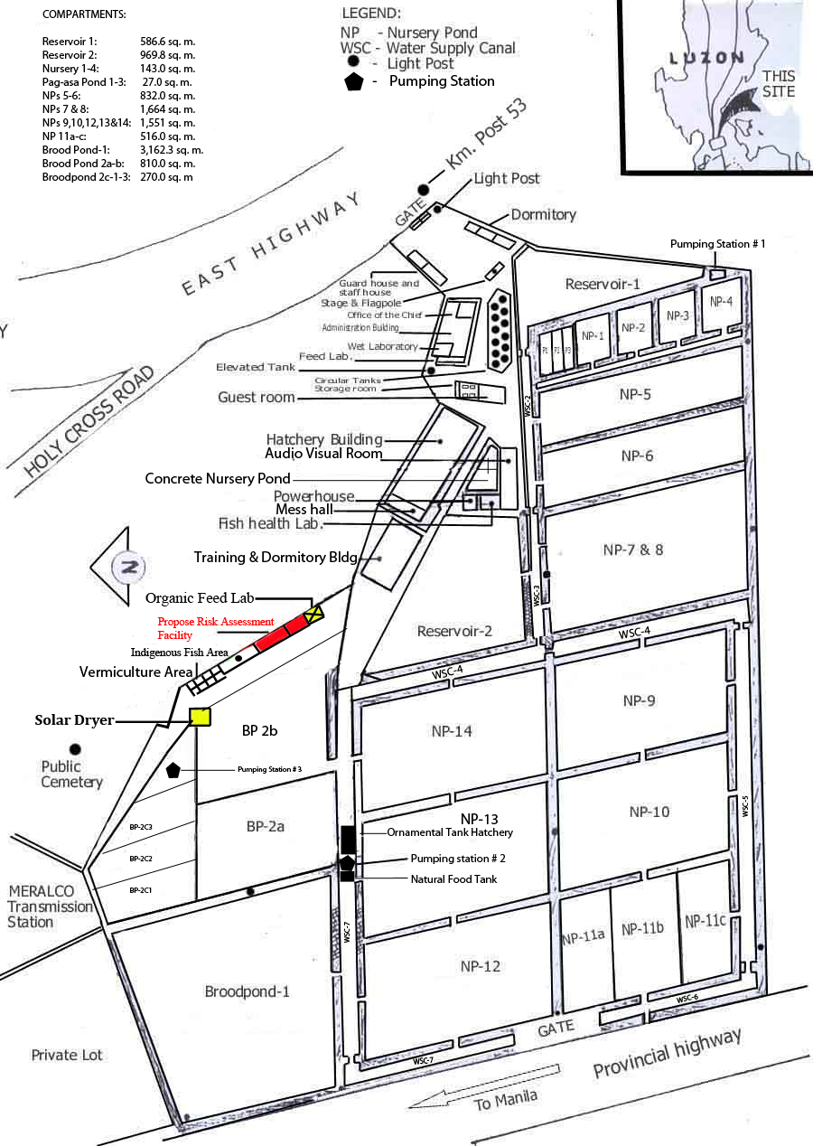

**Figure 2** Area Layout

## Chapter II. SYSTEM ANALYSIS

### 2.1 BUSINESS PROCESSES

**DESCRIPTION OF THE CURRENT PROCESS**

* ATTENDANCE

**Figure 3.** Current attendance flowchart

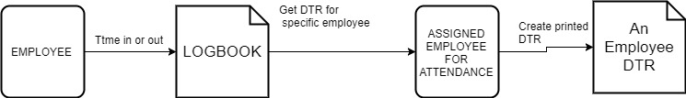

**Figure 4** Current attendance Data flow

The center has a malfunctioning biometric where in most some cases, they’ve manually log attendance in a logbook. An employee summarizes the time in and time out of the system and then generate a report for a specific employee

(see appendix for the DTR of an employee).

* INVENTORY

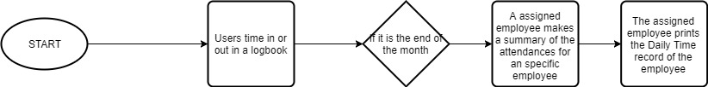

**Figure 5** Current inventory flowchart

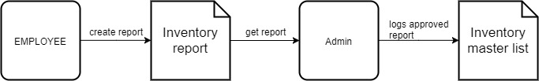

**Figure 6** Current inventory Data flow

The center has a manual logging of items. An employee buys an item with the approval of the admin. Then the employee creates a printed report of the items for the admin and for archives. Then another employee logs all the items report that been signed.

(see appendix for the items report of an employee)

* FISH DISPERSAL

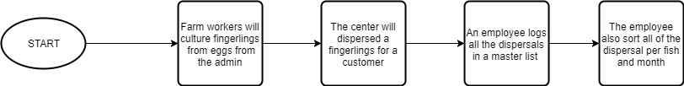

**Figure 7** Current Dispersal flowchart

The center has manual logging of fish that been dispersed or bought. A customer will request a fish then the fish will be cultured. For the most cases the center always cultured a specific breeds of fish like Carp, Tilapia, Ayungin where they are mostly bought by customer. An employee logs all the fish that been dispersed and sort it based on the fish and months.

* FISH PRODUCTION

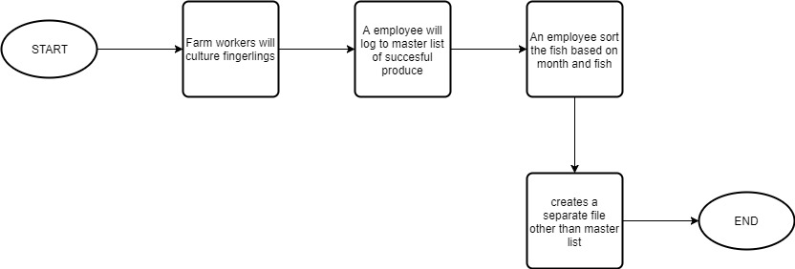

**Figure 8** Current Production flowchart

The center has manual logging of fish that been produce. Not all fingerlings are bought by customer or dispersed so a separate system tracks all production/harvest. An employee sorts all fish or months of all the fish production then creates a separate printed file aside from the production master list

### 2.2 PROBLEM DEFINITION

The BFAR-NIFTC has a limited number of resources to manage their people or to manage their operations. In our survey with them, they’re lacking in inventory management and fish dispersal and fish production management. Having a traditional way of doing paper works or doing some spreadsheet on computer makes an employee occupied than doing more important things.

### 2.3 PROPOSED SOLUTION

The proponents came up with the solution to help the company to manage their employees and to manage all the data of their inventory and their fish production. A local server is made that can be accessed by everyone within the office. The system administrator of BFAR-NIFTC will be assigned as the super administrator of the system. The administrator site of our system has the complete function of the system, where it can add, edit, or delete a data. The system that will be created have 4 sub-system on it, an attendance sub-system, an inventory sub-system, a fish dispersal sub-system, and a fish production sub-system. The attendance sub-system will have a fingerprint sensor to record the attendance of every employees. These records will be in the database and can be exported as a “.csv” file. The inventory sub-system is where all the items were recorded. An item that belongs to the company’s property will be in here and a system administrator can assign an employee when he can access the said sub-system. The fish dispersal sub-system is where they can record the orders that been made in the company and similarly in the fish production sub-system, is the record of all the fishes in their fish ponds and fish tanks. The system administrator can appoint an employee that can be an administrator in each system, to let them manage the sub-system even without the system administrator.

### 2.4 SIGNIFICANCE OF THE STUDY

The findings of this study will redound to the benefit of the company that plays an important role in the country. It will help the company in monitoring all their data and all their employees and the system will make the employees more productive to do important things in the company than doing paper works about recording data. Also it will be significant to all other NIFTC in the Philippines

### 2.5 SCOPE

The proposed solution is composed of an Attendance, Inventory, Fish Dispersal and Fish production. The System is a web application where it has an employee and admin site. The system is host on the system unit from the client. The following are the scope per system:

* Attendance System
  + Users will register their fingerprints in the biometrics, then place their fingerprint if they want to time in or out.
  + In the employee site, users may view/sort their attendance. Users may also add notes if a specific attendance is wrong.
  + In the admin site, Attendance admin can monitor/view/sort all of the attendance from the employees. They also can edit an attendance and export attendances in different formats.
* Inventory System
  + In the employee site, users may view their added items and be sorted, they can also add an item. However, user may not alter the items that has been submitted.
  + In the admin site, Attendance admin can monitor/view/sort all of the attendance from the employees. They also can edit an item and export items in different formats.
* Fish Dispersal
  + In the employee site, users may view/sort all of the orders. They can also add a customer and order. However, user may not alter the order that has been submitted. They can view comparison graphs/table per year sorted by fish.
  + In the admin site, Attendance admin can monitor/view/sort all of the orders from the employees. They also can edit an item and export invoices in different formats.
* Fish Production
  + In the employee site, users may view/sort all of the harvest. They can also add a harvest. However, user may not alter the harvest that has been submitted. They can view comparison graphs/table per year sorted by fish.
  + In the admin site, Fish Production admin can monitor/view/sort all of the harvest from the employees. They also can edit an item and export production in different formats.
* Other Features
  + A calendar used to track events, important dates or even a harvesting schedule.
  + A fish gallery to show to customers the available fish in the center.
  + User may also view other employees profile with data and photo. Users may edit their profile.
* Super Admin
  + Super admin are the ones whose has a complete control of the systems
  + They are the ones who can register a new user/employee of the systems
  + They also dictate whose user may be an Attendance admin, Inventory admin, Dispersal admin or Fish Production Admin.
  + They can view other information from the system like the last login from a user and whose login from the system

### 2.6 LIMITATION

* The systems will only generate table of reports.
* Importing of excel/csv files.
* Data storage capacity it will depend on the system unit that is available.
* Importing and exporting of sql/database.
* Security of the system from outside hackers.

## Chapter III. SYSTEM DESIGN

### 3.1 BUSINESS PROCESSES

**Description of the Proposed Processes**

The proposed is a web based system composed of Attendance, Inventory, Fish Dispersal and Fish Production System. It is composed of an User site and admin site. Also, other features are included like profiles of employees, fish gallery and calendar for fish dispersal and production.

**Homepage**

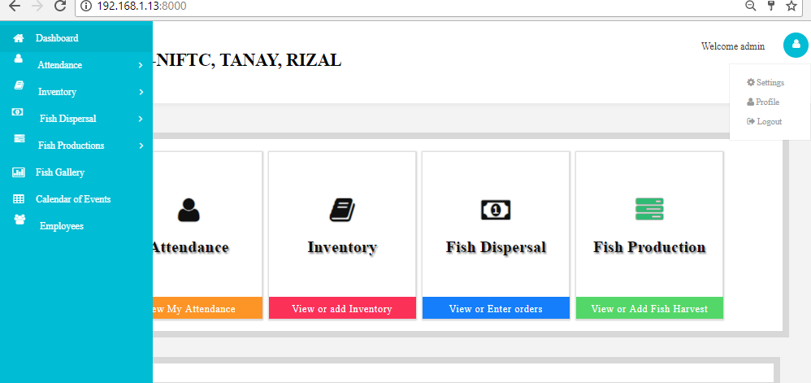

**Figure 9** Homepage 1

The figure above shows the four systems and the side navigations. It also include the profile of the user that is login, Fish Gallery and Employees profile buttons The squares and the navigation are redirected to their respective pages when clicked.

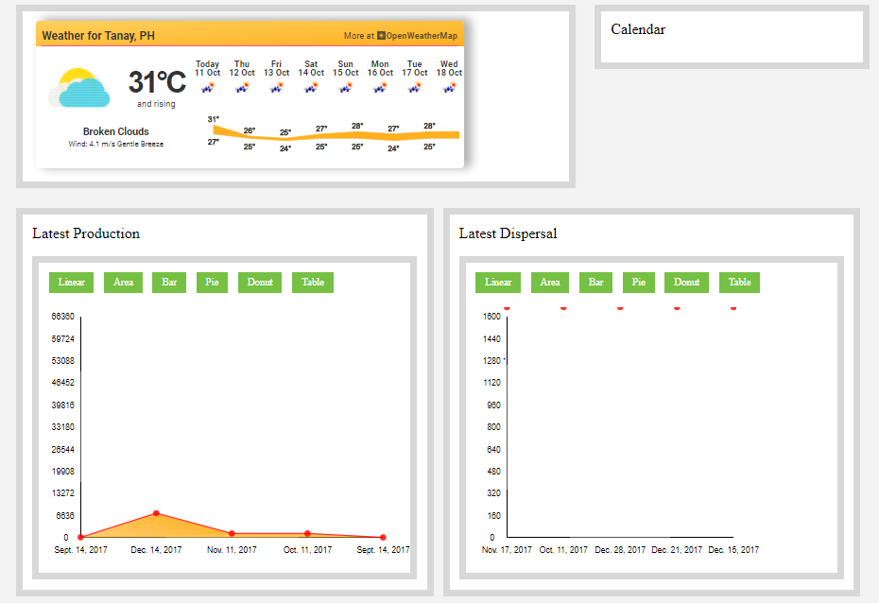

**Figure 10** Homepage 2

The figure above shows the 7 day weather forecast and the most recent fish dispersals and productions.

**Attendance**

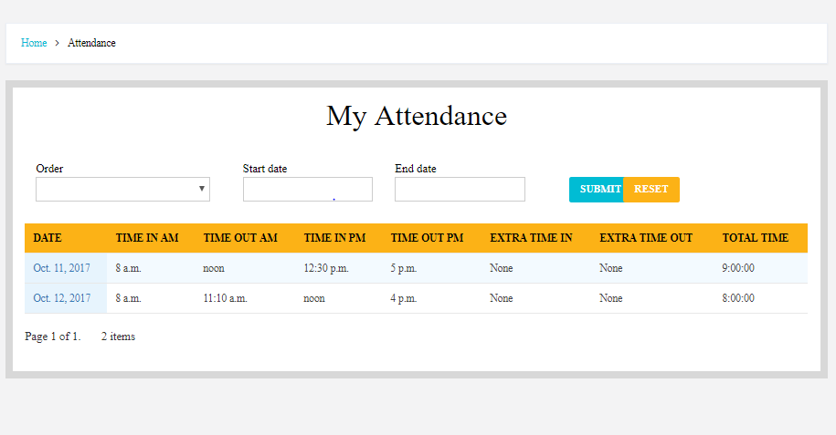

**Figure 11** Attendance view

The figure above shows the updated attendance from the employee. It is separated 20 items per page. When an employee punches his/her fingerprint in the biometrics it automatically updated the database then to the website. By clicking the leftmost column dates, the page will be redirected to the individual page

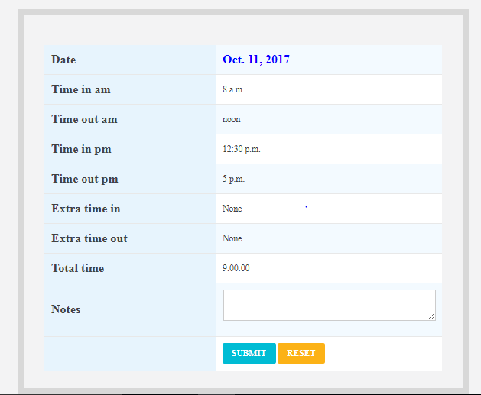

**Figure 12** Attendance edit

The figure above shows the individual attendance pages wherein users can request a change of data by adding notes then the admin will review it in the admin site

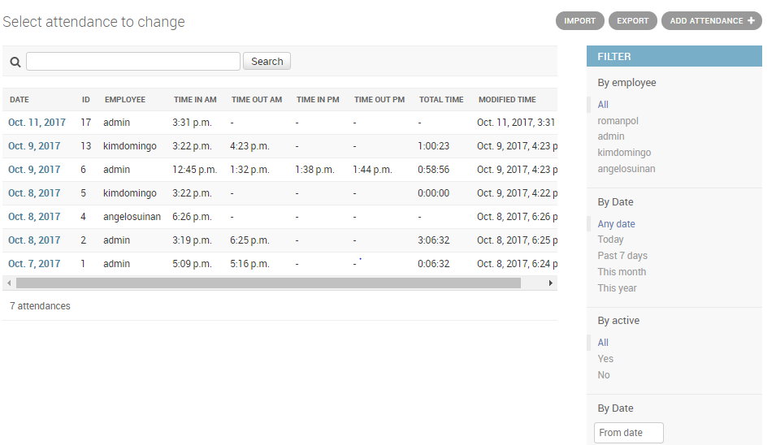

**Figure 13** Attendance admin

The figure above shows the attendance admin. Admin can sort it per employee and dates. Admin can export the sorted queries to different file formats.

**INVENTORY**

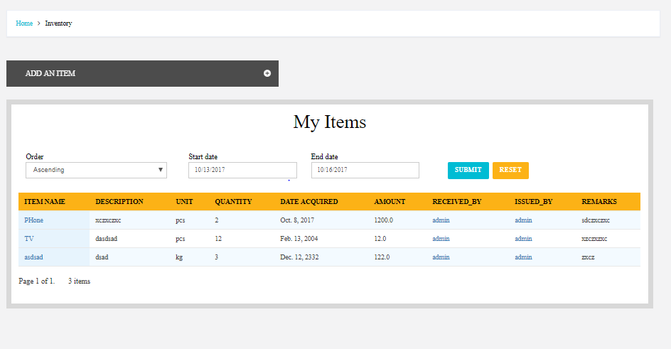

**Figure 14** Inventory View

The figure above shows the items from the currently login users and the add button. It displays 20 items per page and can be sorted by date range and ascending or descending order.

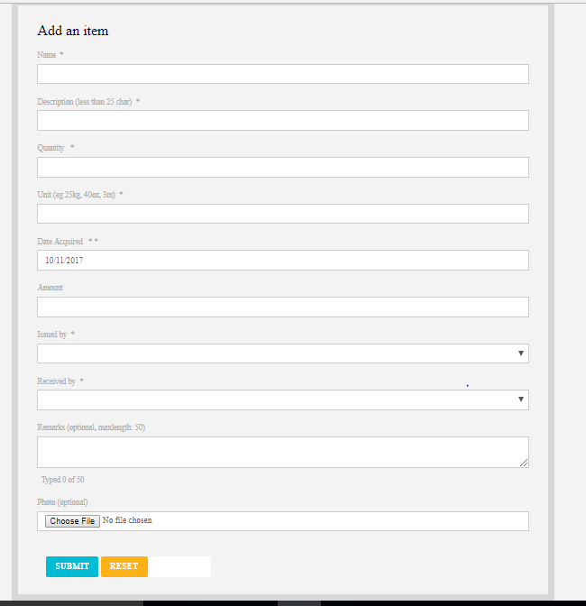

**Figure 15** Inventory Add

The figure above shows the item add form where fields like name, description, quantity and unit are included.

**FISH PRODUCTION**

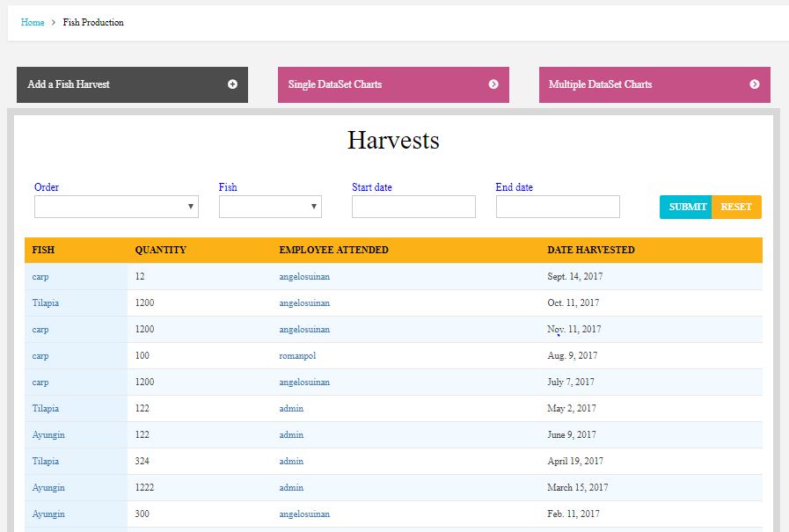

**Figure 16** Production View

The figure above shows the harvest landing page. It can be sorted by fish, order and date range.

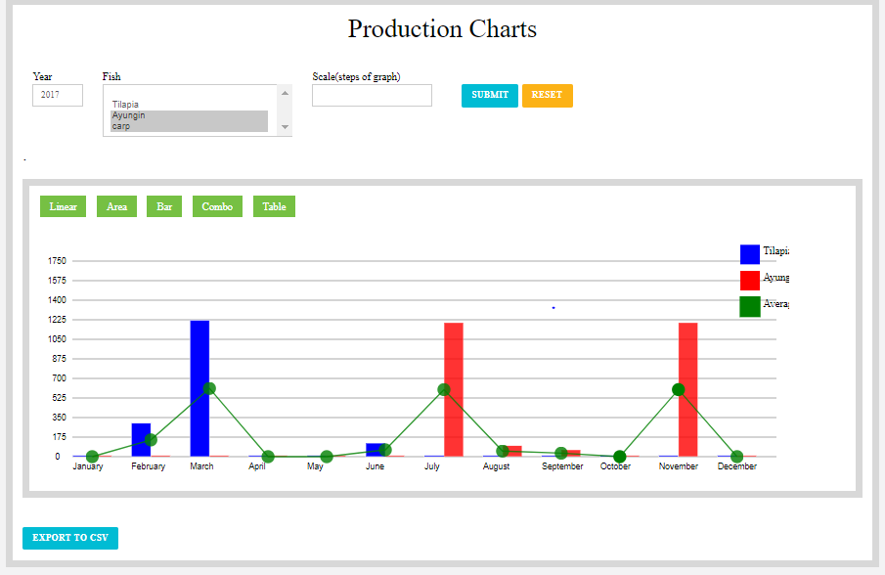

**Figure 17** Production Charts

The figure above shows the harvest charts sorted by year, fish and the scale of the graph can be change. A button below to export the graph into table in CSV format.

**FISH DISPERSAL**

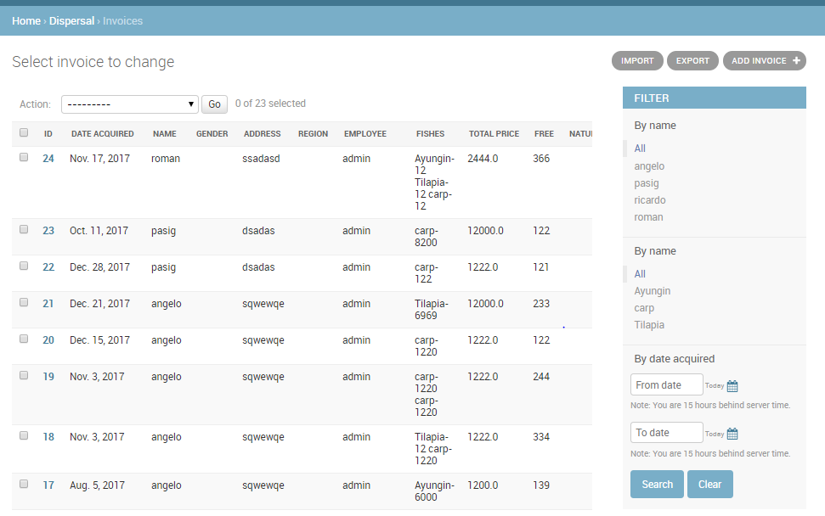

**Figure 18** Dispersal admin

The figure above shows the dispersal admin. Admin can sort it per employee and dates. Admin can export the sorted queries to different file formats.

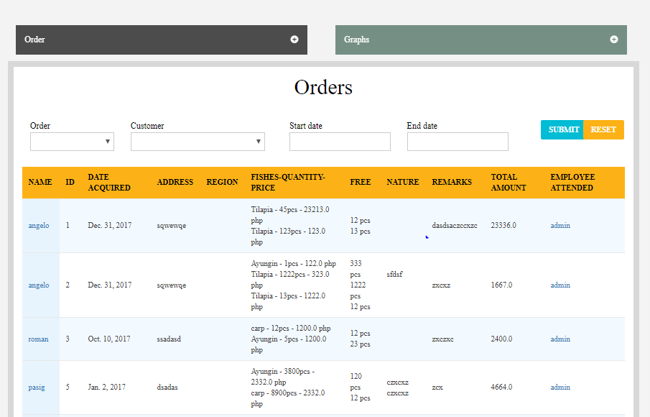

**Figure 19** Dispersal View

The figure above shows the dispersal landing page. It can be sorted by fish, order and date range.

**FLOWCHART**

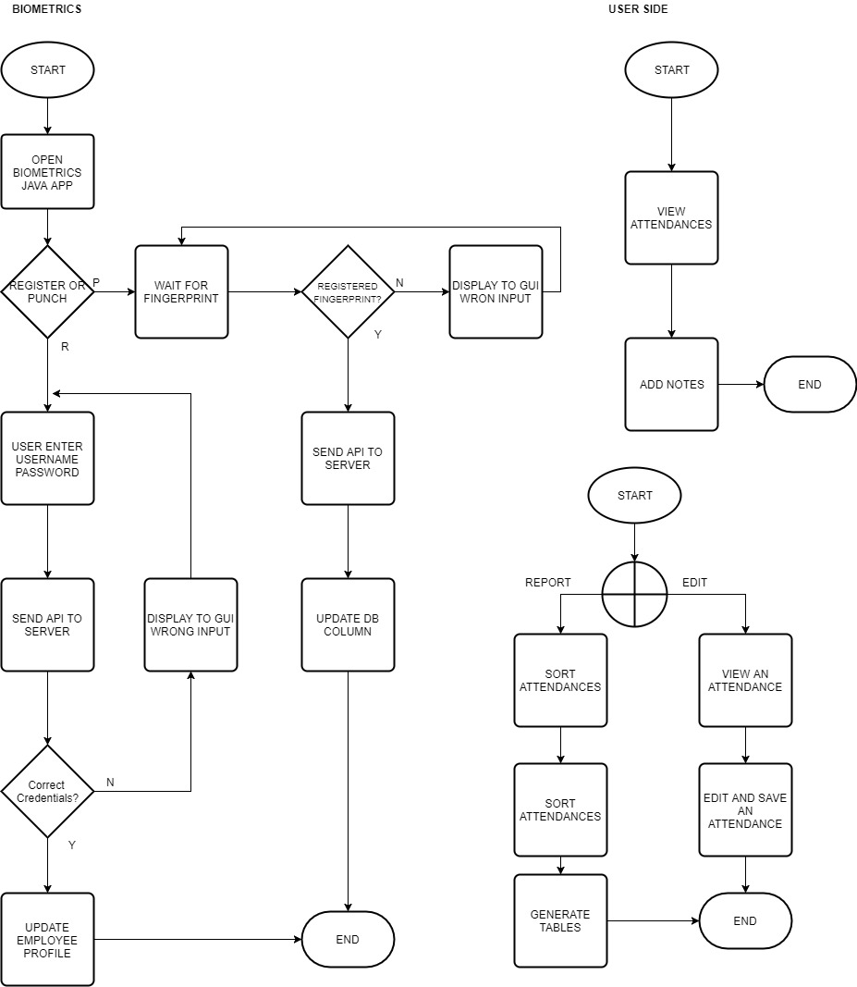

**Figure 20** Flowchart - Attendance

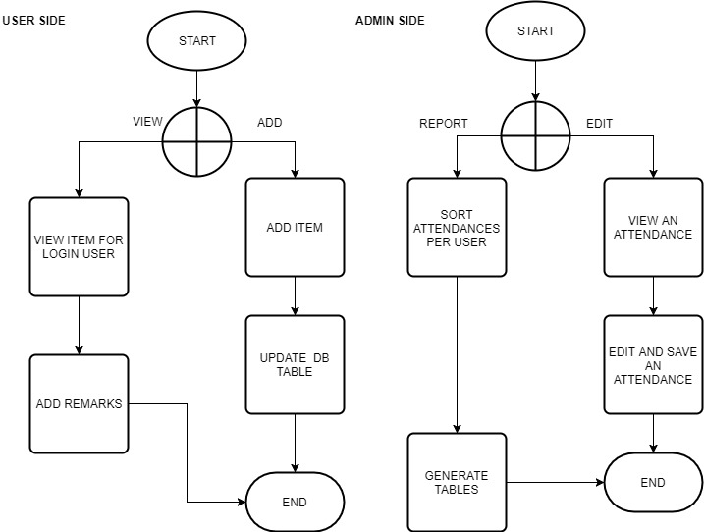

**Figure 21** Flowchart - Inventory

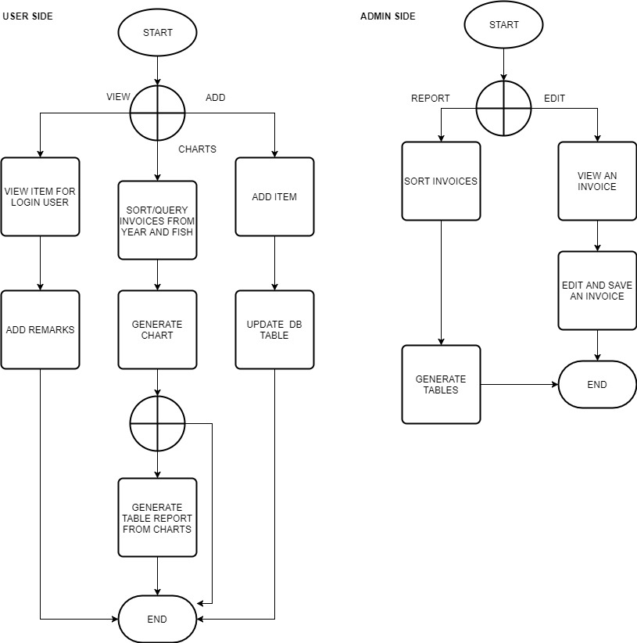

**Figure 22** Flowchart - Fish Dispersal

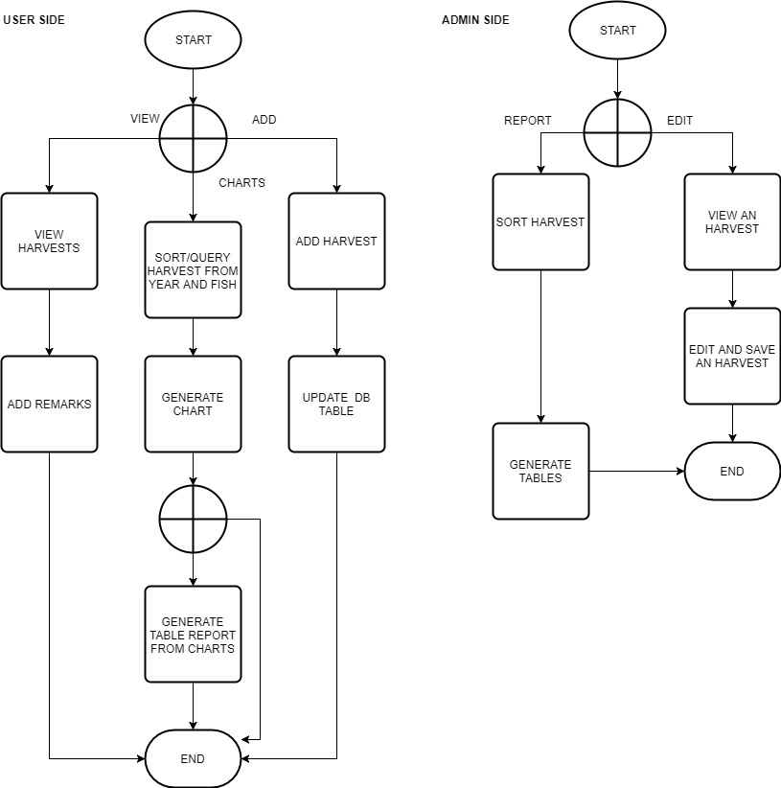

**Figure 23** Flowchart - Fish Production

### 3.2 Data Flow Diagram

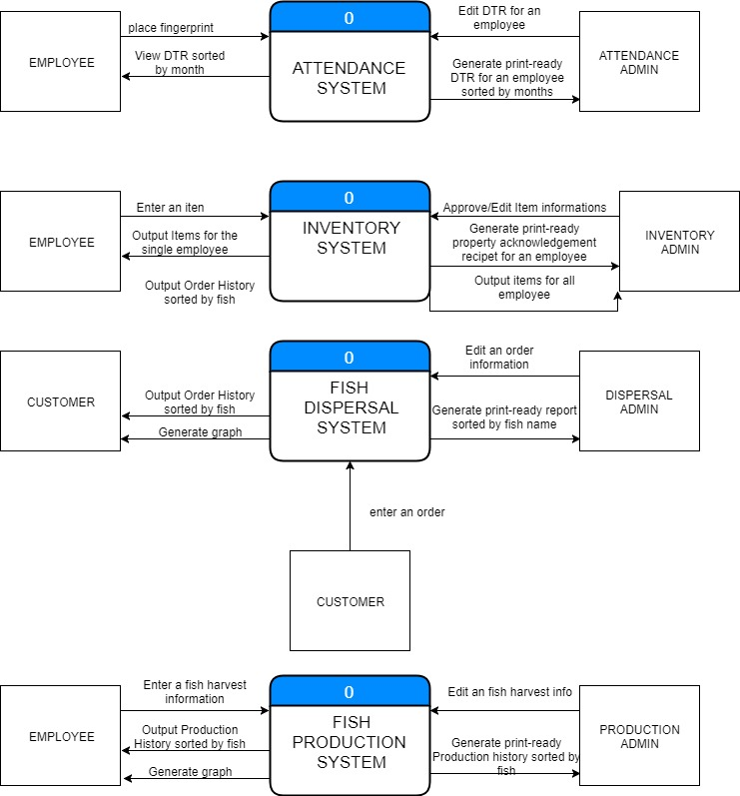

**Figure 24** Context Level Diagram

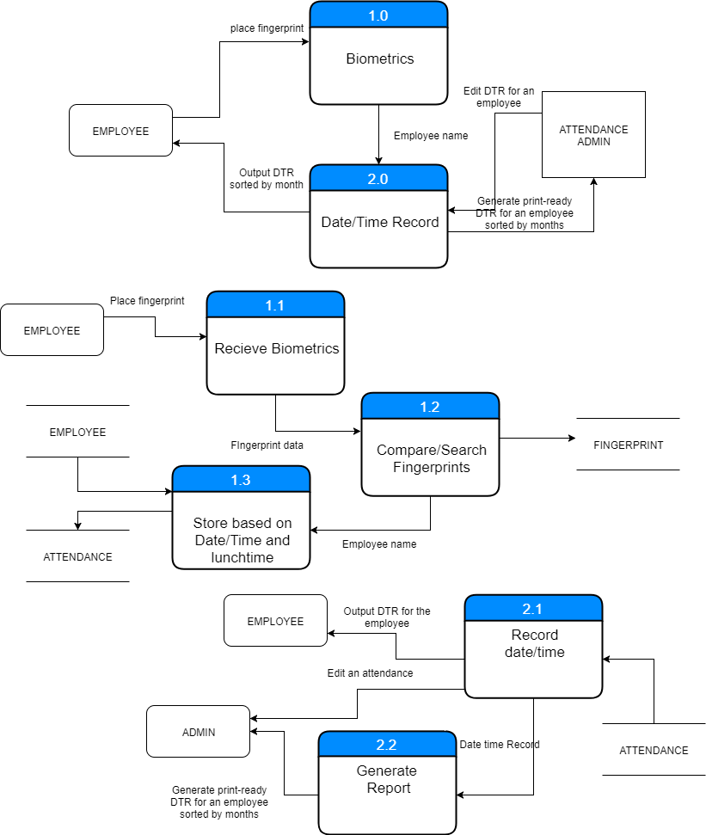

**Figure 25** Child Label Diagram - Attendance

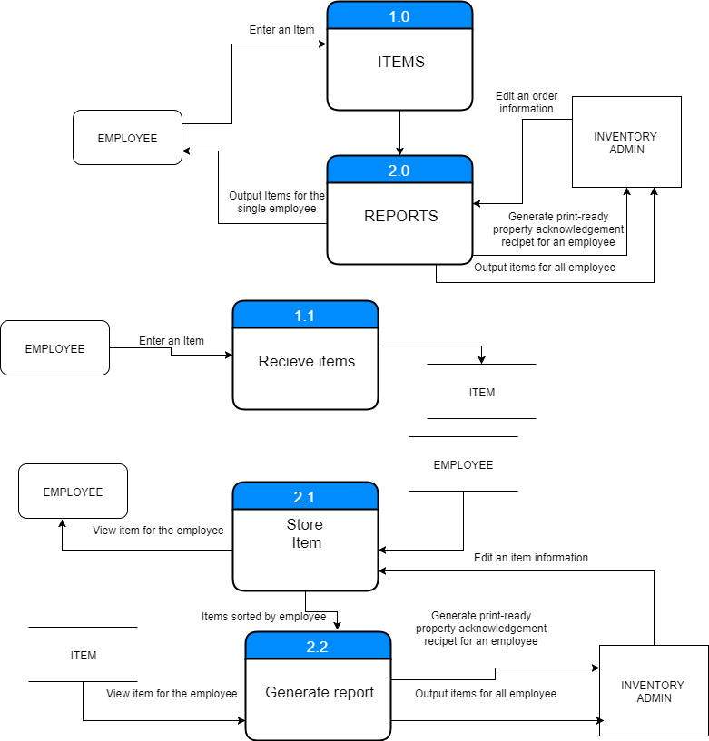

**Figure 26** Child Label Diagram - Inventory

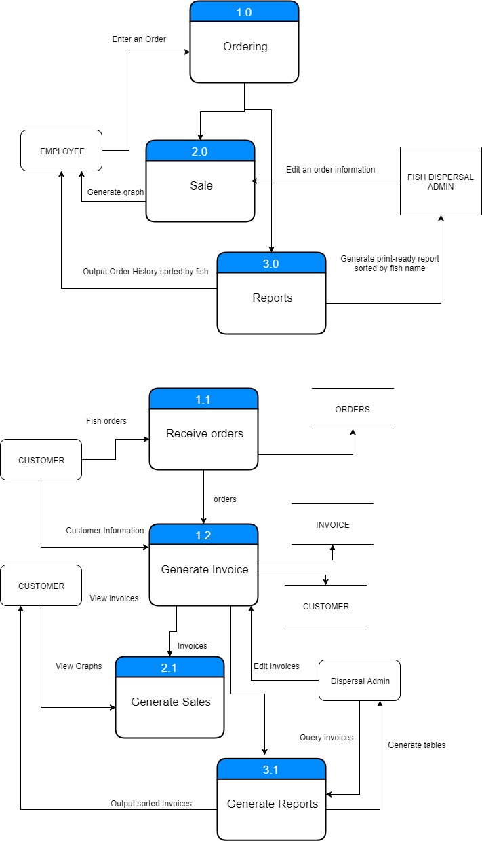

**Figure 27** Child Label Diagram – Fish Dispersal

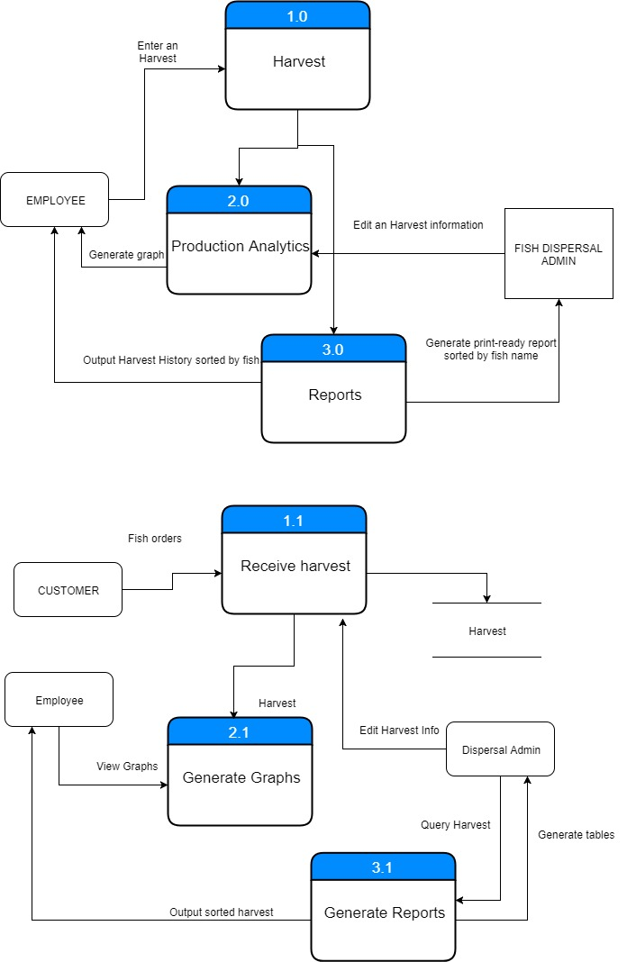

**Figure 28** Child Label Diagram – Fish Production

### 3.1 ENTITY-RELATIONSHIP DIAGRAM

**ENTITY-RELATIONSHIP DIAGRAM**

* **THE DIAGRAM**

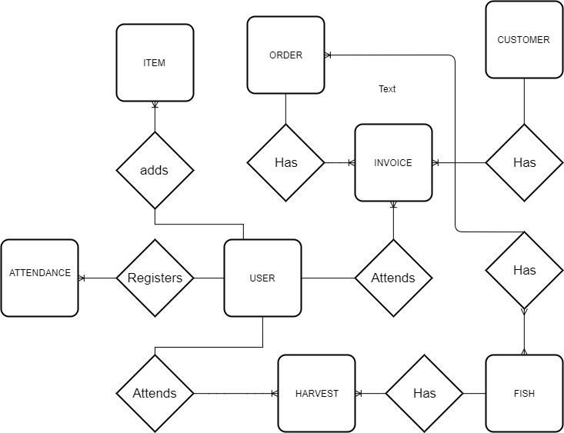

**Figure 29** Entity-Relationship Diagram

* **DATABASE SCHEMA**

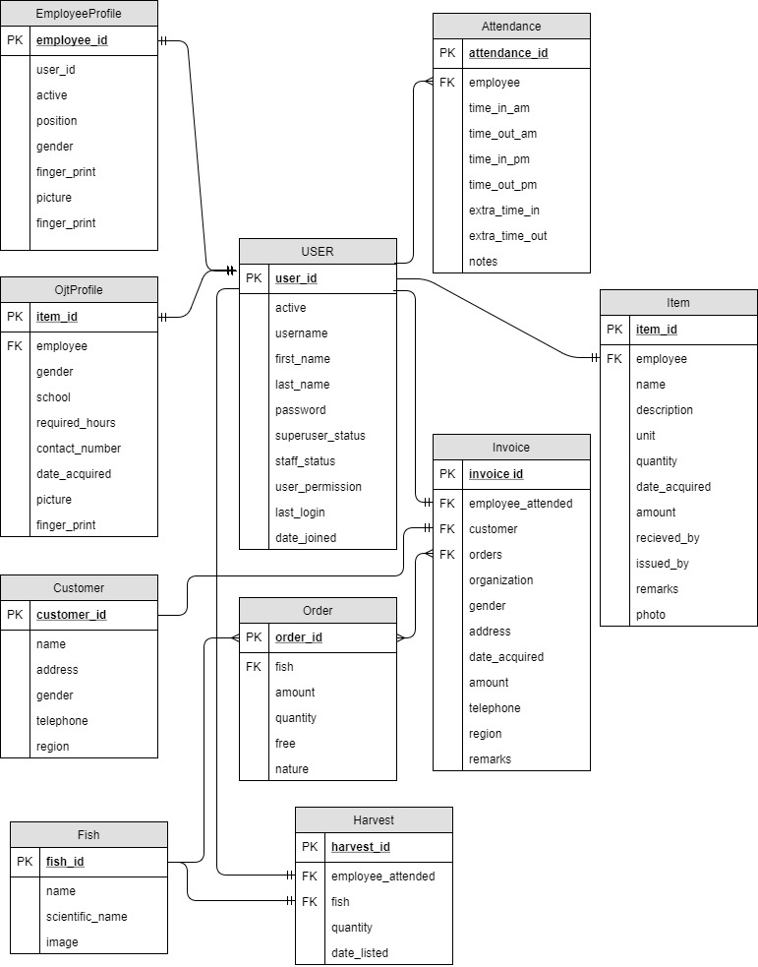

**Figure 30** Child Label Diagram – Fish Disperal

* **DATABASE DICTIONARY**

| **FIELD NAME** | **Data TYPE** | **Constraint** | **Description** |
| --- | --- | --- | --- |
| Id | Int | Primary key | uniqueidentifier |
| username | varchar(150) | Not null | User’s login credential |
| first_name | varchar(30) | optional | User’s first name |
| **last_name** | varchar(30) | optional | User’s last name |
| Email | varchar(50) | optional | User’s email |
| password | varchar(50) | Not null | User’s password |
| Staff status | char(1) | Optional | User’s login credential |
| Active | char(1) | optional | Active user boolean |
| last_login | varchar(15) | optional | User’s login_date |
| Superuser status | Date | Optional | User’s superadmin credentials |
| Date joined | Date | Not null | User’s joined date |
| Groups | Int | Foreign Key | Many to many to groups table |

**Table 1** User Table

| **FIELD NAME** | **Data TYPE** | **Constraint** | **Description** |
| --- | --- | --- | --- |
| Id | Int | Not null | Unique identifier |
| Name | varchar(16-) | Not null | Group name |
| permission | varchar(100) | Optional | Permission to change tables |

**Table 2** Group Table

| **FIELD NAME** | **Data TYPE** | **Constraint** | **Description** |
| --- | --- | --- | --- |
| employee | varchar(150) | Primary Key,Not null | One to many – User table |
| Date | datetime | Not null, | Date |
| Time_in_am | time | Optional | Time in am |
| Time_out_am | time | Optional | Time out pm |
| Time_in_pm | time | Optional | Time in pm |
| Time_out_pm | time | Optional | Time out pm |
| Extra_time_in | time | Optional | Extra time in |
| Extra_time_out | time | Optional | Extra time out |
| Notes | Varchar(150) | Optional |  |

**Table 3** Attendance Table

| **FIELD NAME** | **Data TYPE** | **Constraint** | **Description** |
| --- | --- | --- | --- |
| Id | int | Primary key | Unique identifier |
| Employee | int | Not null, Foreign key | One – Many relationship to USER TABLE |
| Name | Varchar(75) | Not null | Item name |
| Description | varchar(250) | Not null | Item descriptions |
| Unit | Varchar(10) | Not null | Item unit(kg, cm lbs) |
| quantity | Int | Not null | Item quantity |
| Date_acquired | Date | Not null | Item date acquired |
| Issued_by | Int | Not null | One to many relationships to USER |
| Received_by | Int | Not null | One to many relationships to USER |
| Remarks | Varchar(250) | Not null | remarks |

**Table 4** Item Table

**EMPLOYEE PROFILE**

| **FIELD NAME** | **Data TYPE** | **Constraint** | **Description** |
| --- | --- | --- | --- |
| ID | Int | Not null | Unique identifier |
| User | Int | Not null | One to one relationship to User |
| Position | Varchar(30) | Not null | Employee position |
| Gender | Char(2) | Not null | Employee gender |
| address | varchar(50) | Not null | Employee address |
| Contact_number | Varchar(11) | Not null | Employee contact number |
| Finger_print | Boolean | Not null | Employee finger print registered? |
| Photo | Varchar(150) | Not null | Employee photo |

**Table 5** Employee Profile Table

**OJT PROFILE**

|  |  |  |  |
| --- | --- | --- | --- |
| FIELD NAME | Data TYPE | Constraint | Description |
| ID | Int | Not null | Unique identifier |
| User | int | Not null | One to one relationship to User |
| Gender | Char(2) | Not null | OJT gender |
| address | varchar(50) | Not null | OJT address |
| Contact_number | Varchar(11) | Not null | OJT contact number |
| Finger_print | Boolean | Not null | OJT fingerprint registered? |
| Photo | Varchar(150) | Not null | OJT photo |
| School | Varchar(50) | Not null | OJT school |
| Required_hours | Int | Not null | OJT required hours |

**Table 6** OJT Profile Table

**FISH**

| **FIELD NAME** | **Data TYPE** | **Constraint** | **Description** |
| --- | --- | --- | --- |
| id | Int | Primary key | Unique identifier |
| Name | varchar(50) | Not null | Fish name |
| Scientific_name | varchar(75) | Not null | Fish scientific name |
| Image | file | Not null | Fish Image |
| Category | Int | ForeignKey, Not null | Fish Category |

**Table 7** Fish Table

**FISH CATEGORY**

| **FIELD NAME** | **Data TYPE** | **Constraint** | **Description** |
| --- | --- | --- | --- |
| id | Int | Primary key | Unique identifier |
| Name | varchar(50) | Not null | Category name |

**Table 8** Fish Category Table

**CUSTOMER**

| **FIELD NAME** | **Data TYPE** | **Constraint** | **Description** |
| --- | --- | --- | --- |
| id | Int | Primary key | Unique identifier |
| Name | varchar(50) | Not null | customer name |
| Address | Varchar(50) | Not null | Customer address |
| gender | Char(2) | Not null | Customer gender |
| Telephone | Varchar(11) | Not null | Customer telephone |
| Region | Varchar(5) | Not null | Customer region |

**Table 9** Customer Table

**ORDER**

| **FIELD NAME** |  | **Data TYPE** | **Constraint** | **Description** |
| --- | --- | --- | --- | --- |
| id |  | Int | Not null | Unique identifier |
| Fish |  | Int | Not null, Foreignkey | One to many FISH table |
| Amount |  | Int | Not null | Order amount |
| Quantity |  | Int | Not null | Order quantity |
| Free |  | Int | Not null | Order free quantity |
| Nature |  | Varchar(250) | Not null | Order Nature |

**Table 10** Order Table

**Invoice**

| **FIELD NAME** | **Data TYPE** | **Constraint** | **Description** |
| --- | --- | --- | --- |
| Id | Int | Primary key | Unique identifier |
| Customer | Int | Not null, foreignkey | One to many CUSTOMER table |
| Orders | Int | Not, Null, Foreignkey | Many to many ORDER TABLE |
| Employee | Int | Not null, Foreignkey | Many to many USER table |
| Date Acquired | Date | Not null | Orders date acquired |
| Total_price | Int | Not null | Total price of orders |
| Remarks | Varchar(250) | Optional | remarks |

**Table 11** Invoice Table

**HARVEST**

| **FIELD NAME** | **Data TYPE** | **Constraint** | **Description** |
| --- | --- | --- | --- |
| Id | Int | Primary key | Unique identifier |
| Fish | Int | Not null, foreignkey | One to many Fish |
| quantity | Int | Not null, | Harvest quantity |
| Date listed | date | Not, Null, | Date Harvested |
| Employee_attended | int | Not null, Foreignkey | Many to many USER table |
| Remarks | varchar(250) | Optional | remarks |

**Table 12** Harvest Table

## Chapter IV. SYSTEM FEASIBILITY

### 4.1 PROPOSED SOLUTION

The proposed system will be a local server to access its site and be used by all the employees in BFAR-NIFTC.

### 4.1.1 TECHNICAL FEASIBILITY

This assessment is based on an outline design of system requirements, to determine whether the company has the technical expertise to handle completion of the project.

The BFAR-NIFTC is an institution of excellence in sustainable fisheries management and services by 2016; conduct stock assessment and limnological studies of Laguna de Bay and other major lakes/reservoir; develop/verify appropriate aquaculture technologies for packaging, replication and dissemination; organize and implement specialized training courses to upgrade the skills and competence of BFAR regional farm managers/technicians and scientists; and provide specialized advisory/technical services to aquaculture project management and operations.

The BFAR-NIFTC has a limited number of resources to manage their people or to manage their operations. The proponents conduct a survey and in our survey with them, they’re lacking in inventory management and fish dispersal and fish production management. Having a traditional way of doing paper works or doing some spreadsheet on computer makes an employee occupied than doing more important things. The proponents came up with the solution to help the company to manage their employees and to manage all the data of their inventory and their fish production.

### 4.1.1.1 THE PRODUCT(S)/SERVICE(S)

One of the services provided by the BFAR-NIFTC is to sell their cultured fish. In their area, fish tanks and numerous small ponds and big ponds were used to culture the fish. Same kind of fish we’re cultured in the each fish tanks starting from the day before it hatch until it can be sold to a market or buyer. Workers will study and sample the fish every 2 weeks to see if the growth is stable. The proponents came up with the solution to help the company to manage their employees and to manage all the data of their inventory and their fish production. The system that will be created have 4 sub-system on it, an attendance sub-system, an inventory sub-system, a fish dispersal sub-system, and a fish production sub-system. The attendance sub-system will have a fingerprint sensor to record the attendance of every employees. The inventory sub-system is where all the items were recorded. The fish dispersal sub-system is where they can record the orders that been made in the company and similarly in the fish production sub-system, is the record of all the fishes in their fish ponds and fish tanks.

### 4.1.1.2 MANUFACTURING/PRODUCTION PROCESS

On the culturing process, breeding of fish will take place first in the cycle. The fish farmers in BFAR-NIFTC will transfer some of adult fishes and put it on fish tanks separated by its own kind. After they breed eggs, the fish farmers transfer the eggs to another fish tank separated again by its own kind, and putting back the adult fishes on its respective ponds. After several days, the egg will hatch, and the culturing process will begin. In the first stage of culturing process, fish farmers will take care of the hatchlings, making sure that they’re in a safe environment to grow, with the factor of water temperature, oxygen, water level, amount of feeds, and pH level. The fish farmers can start sampling the hatchling every 2 weeks to see its changes because they need to be precise to get the sampling data of the fish because when they sell it, they need the fish not to be full-grown. The majority of buyers in BFAR-NIFTC we’re buying middle-aged fish and then they will continue the culturing process. And that’s when the harvesting comes in, when the fish farmers will harvest the cultured fish and sell it. With the proposed system, employees can immediately see the records of the fish productions, and can set a date where they can harvest the fish. The system also includes the fish dispersal, when they want to sell or manage their orders of the fish.

### 4.1.1.3 SIZE OF THE BUSINESS AND PRODUCTION SCHEDULES

The BFAR-NIFTC is a government institution, meaning the operating days of the company is from Monday-Friday. As for the employees, the fish farmers, and the other workers, they work for 8 hours a day. Regular employees only consists of less than 20 persons. The proposed system has built in “Calendar of Events” whenever they want to launch a project or seminar. Also the system has an attendance sub-system, which monitors the attendance of all the employees. It will have a fingerprint sensor to record the attendance of every employees. These records will be in the database and can be exported as a “.csv” file.

For production schedules, expected growth of the fish to be sell in the market or sell to the buyer need to be accomplish. Financing for the growth and inventory in BFAR-NIFTC we’re manually encoded. Inventory is monitored by putting sticker tags into company’s property. With the proposed system, production schedule can be monitored by putting an exact date to the cultured fish when to be harvest, and orders of the buyers can be add to the database of the system to know the limits of their productions. Inventory can now be added to the database. Lost and damaged items can be labeled in the system, and each user logged in can see their own inventory given to them by the company.

### 4.1.1.4 EQUIPMENT

The BFAR-NIFTC has an inventory list of all their properties. Every items that received or transferred will be recorded manually and also the items that are damaged or lost. Equipment that were mainly used in the company are desktop computers, various types of fish nets and digital pH and temperature meter. These items will be in one database corresponds to each user with our proposed system. The inventory sub-system can manage your own item on the company and the admin of the inventory sub-system can edit and manage all the items of the employees.

### 4.1.1.5 LOCATION AND UTILITIES

The location of BFAR-NIFTC were considered in the proposed system. The system will be accessed through local server. A local server is set-up in the main office and doesn’t require an internet. The system will be needing electricity to run and function properly.

### 4.1.1.6 PRODUCTION COST

For the production cost of the proposed system when the system is now operational, the only constant factor is the electric bill. Laboring for the system is based on the administration of the company. Costing of labor is based on the administration. The overall cost of the system is around PHP 13,000.00.

### 4.1.1.7 SPECIFICATION OF HARDWARE

|  |  |
| --- | --- |
| **HARDWARE USED** | **SPECIFICATION** |
| Raspberry Pi 3 | * SoC: Broadcom BCM2837 * CPU: 1.2 GHZ quad-core ARM Cortex A53 * GPU: Broadcom VideoCore IV @ 400 MHz * Memory: 1 GB LPDDR2-900 SDRAM * USB ports: 4 * Network: 10/100 MBPS Ethernet, 802.11n Wireless LAN, Bluetooth 4.0 |
| LAN Modem | * Ethernet network adapter * Connection Speed: 150 Mbps |
| RJ45 LAN Cable | * 20 meter in length |
| Fingerprint Scanner | * Standalone Fingerprint Scanner via USB |

**Table 13** Specification of Hardware

### 4.1.1.8 SPECIFICATION OF SOFTWARE

The following software is used for the development of the system:

* + - Linux Mint
    - Python
    - Django

### 4.1.2 OPERATIONAL FEASIBILITY

Operational feasibility is a measure of how well a proposed system solves the problems, and takes advantage of the opportunities identified during scope definition and how it satisfies the requirements identified in the requirements analysis phase of system development. Operational feasibility reviews the willingness of the organization to support the proposed system. This is probably the most difficult of the feasibilities to gauge. In order to determine this feasibility, it is important to understand the management commitment to the proposed project. If the request was initiated by management, it is likely that there is management support and the system will be accepted and used. However, it is also important that the employee base will be accepting of the change. The operational feasibility is the one that will be used effectively after it has been developed. If users have difficulty with a new system, it will not produce the expected benefits.

The proponent system needs to have an electricity to run and need at least 2 system administrator to manage.

The proposed system solves one the issues in BFAR-NIFTC, the manual labor of gathering of data or monitoring the employees and at the same time the inventory of the company and the keeping of data of all the fish productions and fish dispersal, making more workers to work on their job than to spend paper works on the said sub-systems.

To ensure the success of the project, desired operational outcomes will be imparted in the design and development. Reliability, maintainability, supportability, usability, sustainability and affordability are the passed parameters of our system.

Laboring for the system is based on the administration of the company but a system administrator must be the one to labor the whole system. Costing of labor is based on the administration. Labor is generally classified into three types: the administrative, the direct and the indirect. The administrative is the one who controls and use the proposed system and it must be the system administrator of the company. The direct is the one that will handle the sub-systems or the administrator of the sub-systems. The direct may be the regular employees that is assigned by the administration to handle such sub-systems. The indirect is the one that has no administrative privilege to the system but is a user and can manage their attendance and other stuff in the system

The BFAR-NIFTC is managed and run by the OIC, Adan S. Diamante (Aquaculturist II), and with his other permanent employees, Romualdo Pol (Sr. Aquaculturist), Rosebella Valencia (Aquaculturist I), Nicanor Crisostomo (Security Guard I), and Danilo Sinquenco (Administrative Aide III). For the production job orders, 5 employees were assigned, Pepito Bicera Jr, Rolando Magalona, Rodrigo Lofranco. Rowel Bautista and Ronald Gimenez. In the technical job orders, 3 employees were assigned, Marvin F. Costo (BS Biologist), Julius Aran (BS Biologist), Ferdinand Vocal (BS Fisheries). And for other job orders, 2 employees were assigned, Lyn San Jose (RA Knifefish, BS Fisheries) and Jasper Paul Ancheta (Agricultural Engineer, NIFEP).

### 4.1.3 ECONOMICAL FEASIBILITY

Given the financial resource of the company and the proponent, the proposed system can be completed. The labor for this system can be included to the system administrator’s labor and the administration is one who will labor its employee who’s actively handle the sub-systems. The investment to this system is justified and its benefits outweigh the cost. With the system used, compare to the manual laboring of getting, analyzing and sorting data in the company and managing people and resources, the effectiveness of the system passed the criteria in the said feasibility.

Cost benefit analysis (CBA) is a systematic approach to estimate the strengths and weaknesses of alternatives; it is used to determine options that provide the best approach to achieve benefits while preserving savings. The CBA is also defined as a systematic process for calculating and comparing benefits and costs of a decision, policy (with particular regard to government policy) or (in general) project.

### 4.1.3.1 OPERATIONAL COST

|  |  |
| --- | --- |
| Bill of electricity | PHP 500.00 per month |
| Computer Operator | PHP 5,000.00 per month |
| Network Technician | PHP 5,000.00 |
| Computer Technician | PHP 5,000.00 |
| System Administrator | PHP 20,000 per month |
| **TOTAL** | PHP 25,500 per month + PHP 10,000 for technical problems |

**Table 14** Operational Cost

### 4.1.3.2 TECHNICAL COST

|  |  |
| --- | --- |
| **HARDWARE** |  |
| Raspberry Pi 3 | PHP 3,000.00 |
| LAN Modem | PHP 3,000.00 |
| LAN Cable | PHP 2,000.00 |
| Fingerprint Scanner | PHP 4,000.00 |
| **TOTAL** | PHP 13,000.00 |

**Table 15** Technical Cost

### 4.2 ALTERNATIVE SOLUTION

The alternative solution for the proposed system if there are stable internet access on the area will be via cloud through a web server to access its site and be used by all the employees in BFAR-NIFTC.

### 4.2.1 TECHNICAL FEASIBILITY

This assessment is based on an outline design of system requirements, to determine whether the company has the technical expertise to handle completion of the project.

The BFAR-NIFTC is an institution of excellence in sustainable fisheries management and services by 2016; conduct stock assessment and limnological studies of Laguna de Bay and other major lakes/reservoir; develop/verify appropriate aquaculture technologies for packaging, replication and dissemination; organize and implement specialized training courses to upgrade the skills and competence of BFAR regional farm managers/technicians and scientists; and provide specialized advisory/technical services to aquaculture project management and operations.

The BFAR-NIFTC has a limited number of resources to manage their people or to manage their operations. The proponents conduct a survey and in our survey with them, they’re lacking in inventory management and fish dispersal and fish production management. Having a traditional way of doing paper works or doing some spreadsheet on computer makes an employee occupied than doing more important things. The proponents came up with the solution to help the company to manage their employees and to manage all the data of their inventory and their fish production.

### 4.2.1.1 THE PRODUCT(S)/SERVICE(S)

One of the services provided by the BFAR-NIFTC is to sell their cultured fish. In their area, fish tanks and numerous small ponds and big ponds were used to culture the fish. Same kind of fish we’re cultured in the each fish tanks starting from the day before it hatch until it can be sold to a market or buyer. Workers will study and sample the fish every 2 weeks to see if the growth is stable. The proponents came up with the solution to help the company to manage their employees and to manage all the data of their inventory and their fish production. The system that will be created have 4 sub-system on it, an attendance sub-system, an inventory sub-system, a fish dispersal sub-system, and a fish production sub-system. The attendance sub-system will have a fingerprint sensor to record the attendance of every employees. The inventory sub-system is where all the items were recorded. The fish dispersal sub-system is where they can record the orders that been made in the company and similarly in the fish production sub-system, is the record of all the fishes in their fish ponds and fish tanks.

### 4.2.1.2 MANUFACTURING/PRODUCTION PROCESS

On the culturing process, breeding of fish will take place first in the cycle. The fish farmers in BFAR-NIFTC will transfer some of adult fishes and put it on fish tanks separated by its own kind. After they breed eggs, the fish farmers transfer the eggs to another fish tank separated again by its own kind, and putting back the adult fishes on its respective ponds. After several days, the egg will hatch, and the culturing process will begin. In the first stage of culturing process, fish farmers will take care of the hatchlings, making sure that they’re in a safe environment to grow, with the factor of water temperature, oxygen, water level, amount of feeds, and pH level. The fish farmers can start sampling the hatchling every 2 weeks to see its changes because they need to be precise to get the sampling data of the fish because when they sell it, they need the fish not to be full-grown. The majority of buyers in BFAR-NIFTC we’re buying middle-aged fish and then they will continue the culturing process. And that’s when the harvesting comes in, when the fish farmers will harvest the cultured fish and sell it. With the proposed system, employees can immediately see the records of the fish productions, and can set a date where they can harvest the fish. The system also includes the fish dispersal, when they want to sell or manage their orders of the fish.

### 4.2.1.3 SIZE OF THE BUSINESS AND PRODUCTION SCHEDULES

The BFAR-NIFTC is a government institution, meaning the operating days of the company is from Monday-Friday. As for the employees, the fish farmers, and the other workers, they work for 8 hours a day. Regular employees only consists of less than 20 persons. The proposed system has built in “Calendar of Events” whenever they want to launch a project or seminar. Also the system has an attendance sub-system, which monitors the attendance of all the employees. It will have a fingerprint sensor to record the attendance of every employees. These records will be in the database and can be exported as a “.csv” file.

For production schedules, expected growth of the fish to be sell in the market or sell to the buyer need to be accomplish. Financing for the growth and inventory in BFAR-NIFTC we’re manually encoded. Inventory is monitored by putting sticker tags into company’s property. With the proposed system, production schedule can be monitored by putting an exact date to the cultured fish when to be harvest, and orders of the buyers can be add to the database of the system to know the limits of their productions. Inventory can now be added to the database. Lost and damaged items can be labeled in the system, and each user logged in can see their own inventory given to them by the company.

### 4.2.1.4 EQUIPMENT

The BFAR-NIFTC has an inventory list of all their properties. Every items that received or transferred will be recorded manually and also the items that are damaged or lost. Equipment that were mainly used in the company are desktop computers, various types of fish nets and digital pH and temperature meter. These items will be in one database corresponds to each user with our proposed system. The inventory sub-system can manage your own item on the company and the admin of the inventory sub-system can edit and manage all the items of the employees.

### 4.2.1.5 LOCATION AND UTILITIES

The system will be accessible via web. A host server is set-up in cloud. The system will be needing electricity to run and function properly.

### 4.2.1.6 PRODUCTION COST

For the production cost of the proposed system when the system is now operational, the only constant factor is the electric bill. Laboring for the system is based on the administration of the company. Costing of labor is based on the administration. The overall cost of the system is around PHP 9,000.00.

### 4.2.1.7 SPECIFICATION OF HARDWARE

|  |  |
| --- | --- |
| **HARDWARE USED** | **SPECIFICATION** |
| LAN Modem | * Ethernet network adapter * Connection Speed: 150 Mbps |
| RJ45 LAN Cable | * 20 meter in length |
| Internet Modem | * Connection Speed: 150 Mbps |
| Fingerprint Scanner | * Standalone Fingerprint Scanner via USB |

**Table 16** Specification of Hardware

### 4.2.1.8 SPECIFICATION OF SOFTWARE

The following software is used for the development of the system:

* + - Cloud SERVER

### 4.2.2 OPERATIONAL FEASIBILITY

Operational feasibility is a measure of how well a proposed system solves the problems, and takes advantage of the opportunities identified during scope definition and how it satisfies the requirements identified in the requirements analysis phase of system development. Operational feasibility reviews the willingness of the organization to support the proposed system. This is probably the most difficult of the feasibilities to gauge. In order to determine this feasibility, it is important to understand the management commitment to the proposed project. If the request was initiated by management, it is likely that there is management support and the system will be accepted and used. However, it is also important that the employee base will be accepting of the change. The operational feasibility is the one that will be used effectively after it has been developed. If users have difficulty with a new system, it will not produce the expected benefits.

The proponent system needs to have an electricity to run and need at least 2 system administrator to manage.

The proposed system solves one the issues in BFAR-NIFTC, the manual labor of gathering of data or monitoring the employees and at the same time the inventory of the company and the keeping of data of all the fish productions and fish dispersal, making more workers to work on their job than to spend paper works on the said sub-systems.

To ensure the success of the project, desired operational outcomes will be imparted in the design and development. Reliability, maintainability, supportability, usability, sustainability and affordability are the passed parameters of our system.

Laboring for the system is based on the administration of the company but a system administrator must be the one to labor the whole system. Costing of labor is based on the administration. Labor is generally classified into three types: the administrative, the direct and the indirect. The administrative is the one who controls and use the proposed system and it must be the system administrator of the company. The direct is the one that will handle the sub-systems or the administrator of the sub-systems. The direct may be the regular employees that is assigned by the administration to handle such sub-systems. The indirect is the one that has no administrative privilege to the system but is a user and can manage their attendance and other stuff in the system

The BFAR-NIFTC is managed and run by the OIC, Adan S. Diamante (Aquaculturist II), and with his other permanent employees, Romualdo Pol (Sr. Aquaculturist), Rosebella Valencia (Aquaculturist I), Nicanor Crisostomo (Security Guard I), and Danilo Sinquenco (Administrative Aide III). For the production job orders, 5 employees were assigned, Pepito Bicera Jr, Rolando Magalona, Rodrigo Lofranco. Rowel Bautista and Ronald Gimenez. In the technical job orders, 3 employees were assigned, Marvin F. Costo (BS Biologist), Julius Aran (BS Biologist), Ferdinand Vocal (BS Fisheries). And for other job orders, 2 employees were assigned, Lyn San Jose (RA Knifefish, BS Fisheries) and Jasper Paul Ancheta (Agricultural Engineer, NIFEP).

### 4.2.3 ECONOMICAL FEASIBILITY

Given the financial resource of the company and the proponent, the proposed system can be completed. The labor for this system can be included to the system administrator’s labor and the administration is one who will labor its employee who’s actively handle the sub-systems. The investment to this system is justified and its benefits outweigh the cost. With the system used, compare to the manual laboring of getting, analyzing and sorting data in the company and managing people and resources, the effectiveness of the system passed the criteria in the said feasibility.

Cost benefit analysis (CBA) is a systematic approach to estimate the strengths and weaknesses of alternatives; it is used to determine options that provide the best approach to achieve benefits while preserving savings. The CBA is also defined as a systematic process for calculating and comparing benefits and costs of a decision, policy (with particular regard to government policy) or (in general) project.

### 4.2.3.1 OPERATIONAL COST

|  |  |
| --- | --- |
| Bill of electricity | PHP 500.00 per month |
| Bill of internet | PHP 2,000.00 per month |
| Computer Operator | PHP 5,000.00 per month |
| Network Technician | PHP 5,000.00 |
| Computer Technician | PHP 5,000.00 |
| System Administrator | PHP 20,000 per month |
| **TOTAL** | PHP 27,500 per month + PHP 10,000 for technical problems |

**Table 17** Operational Cost

### 4.2.3.2 TECHNICAL COST

|  |  |
| --- | --- |
| **HARDWARE** |  |
| LAN Modem | PHP 3,000.00 |
| LAN Cable | PHP 2,000.00 |
| Fingerprint Scanner | PHP 4,000.00 |
| **SOFTWARE** | PHP 50,000 |
| **TOTAL** | PHP 59,000.00 |

**Table 18** Technical Cost

## Appendices

**REFERENCES**

*NATIONAL INLAND FISHERIES TECHNOLOGY CENTER (NIFTC)*. (n.d.). Retrieved October 3, 2017, from <https://www.bfar.da.gov.ph/about_us.jsp?id=36>

**APPENDICES**

**PERTINENT DOCUMENTS**



**Figure 31** Generated tables from Attendance



**Figure 32** Generated tables from Dispersal



**Figure 33** Generated tables from Production



**Figure 34** Generated tables from Dispersal production

**EXISTING FORMS FROM THE COMPANY**

Daily Time Record of an Employee

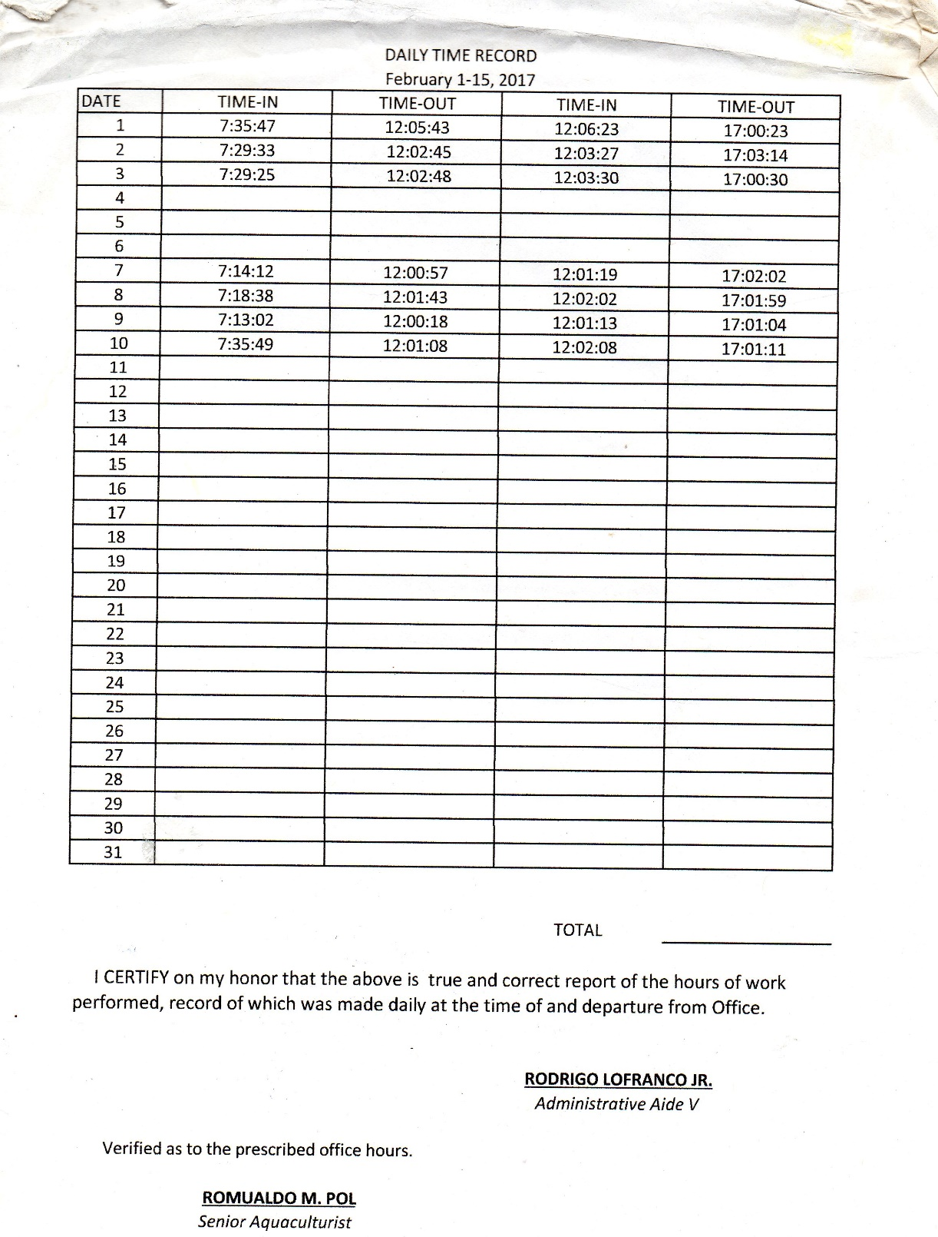

**Figure 37** Existing DTR

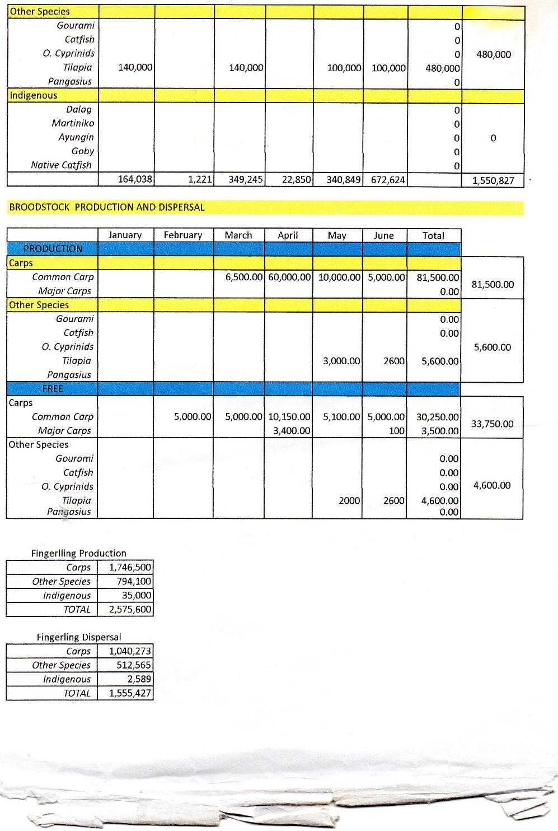

**Figure 36** Existing dispersal and production 1

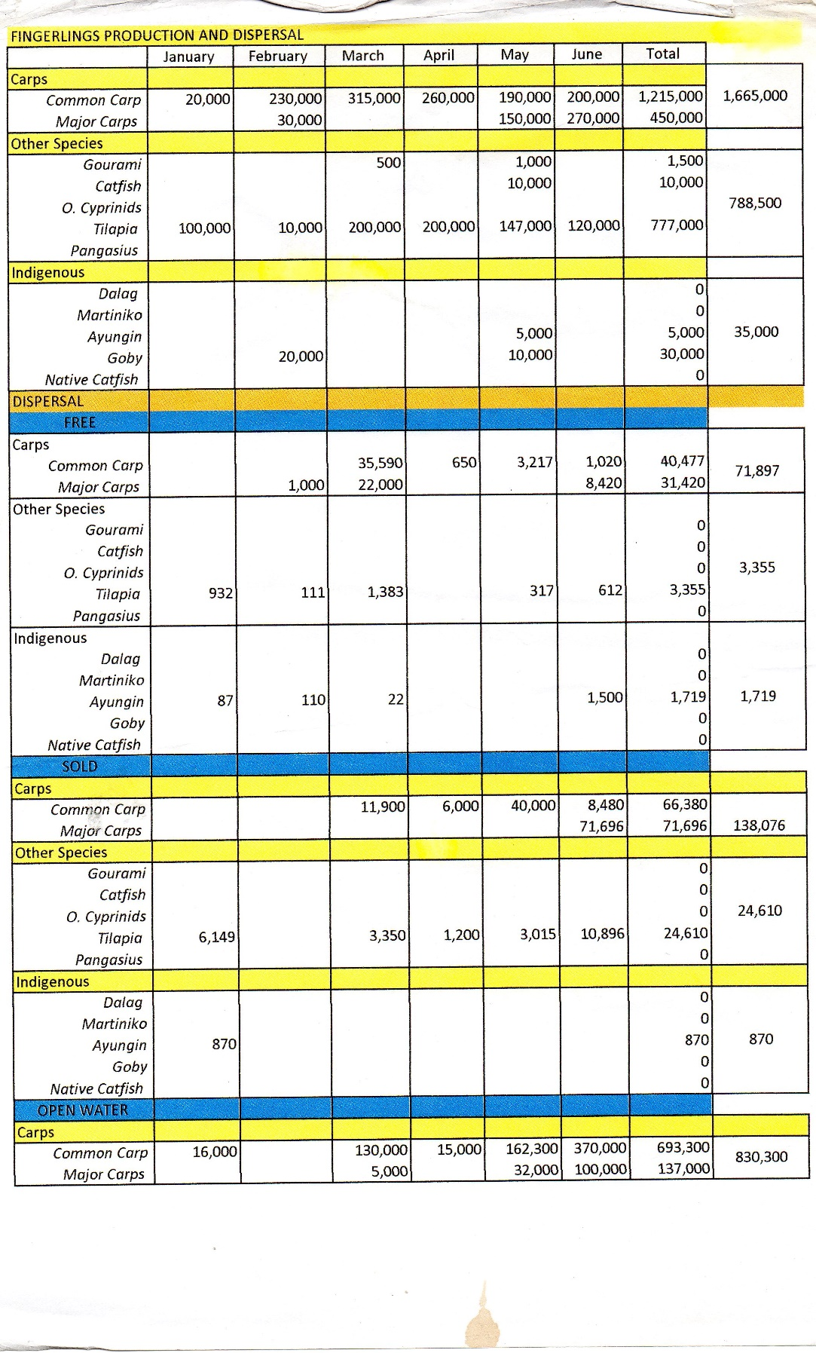

**Figure 36** Existing dispersal and production 2

**GANTT CHART/PERT/CPM**

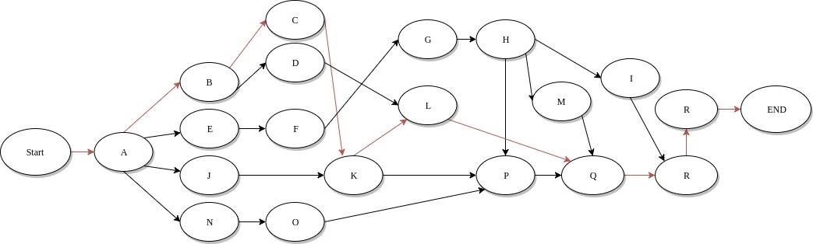

**Figure 37** CPM

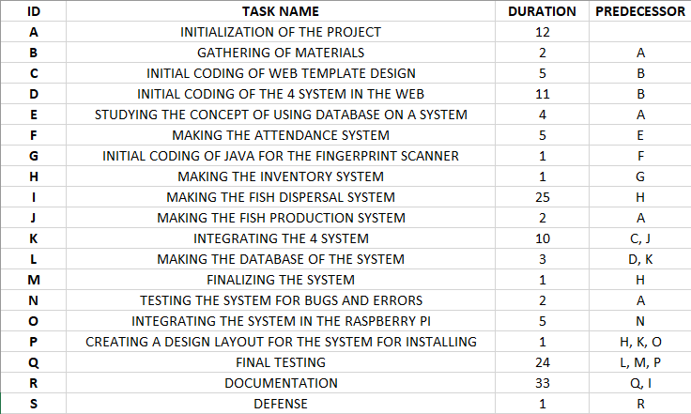

**Figure 38** Timeline

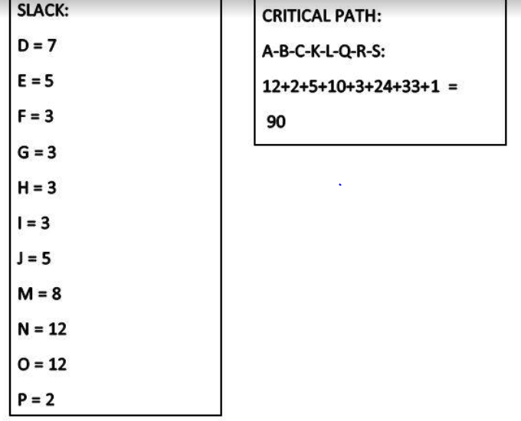

**Figure 39** Critical path Computation